Leveraging LeNet for Jetson Nano Edge AI Applications
August, 2023

- Account detail:
Account name：xt
Password：12345
- Installation guidance of caffe on Jetson nano：
#install dependencies
$ sudo apt-get install cmake git unzip
$ sudo apt-get install libgoogle-glog-dev libgflags-dev
$ sudo apt-get install libprotobuf-dev libleveldb-dev liblmdb-dev
$ sudo apt-get install libsnappy-dev libhdf5-serial-dev protobuf-compiler
$ sudo apt-get install --no-install-recommends libboost-all-dev
$ sudo apt-get install libatlas-base-dev libopenblas-dev
$ sudo apt-get install the python3-dev python3-skimage
$ sudo -H pip3 install pydot
$ sudo apt-get install graphviz

#download caffe
$ cd ~
$ wget -O caffe.zip https://github.com/Qengineering/caffe/archive/ssd.zip
$ unzip caffe.zip
$ mv caffe-ssd caffe

#build caffe
$ cd ~/caffe
# select the configuration
$ cp Makefile.config.JetsonNano_example Makefile.config
# start the build
$ make clean
$ make all -j4
$ make test -j4
$ make runtest -j4

#if you want to run caffe in python3
# Assuming you're still in ~/caffe
$ make pycaffe
$ make pytest

#Add caffe to your PYTHONPATH
$ cd ~
$ sudo nano ~/.bashrc
# at the end of the file add the next line
export PYTHONPATH="${PYTHONPATH}:$HOME/caffe/python"
# save and close with
Ctrl+X, Y, Enter
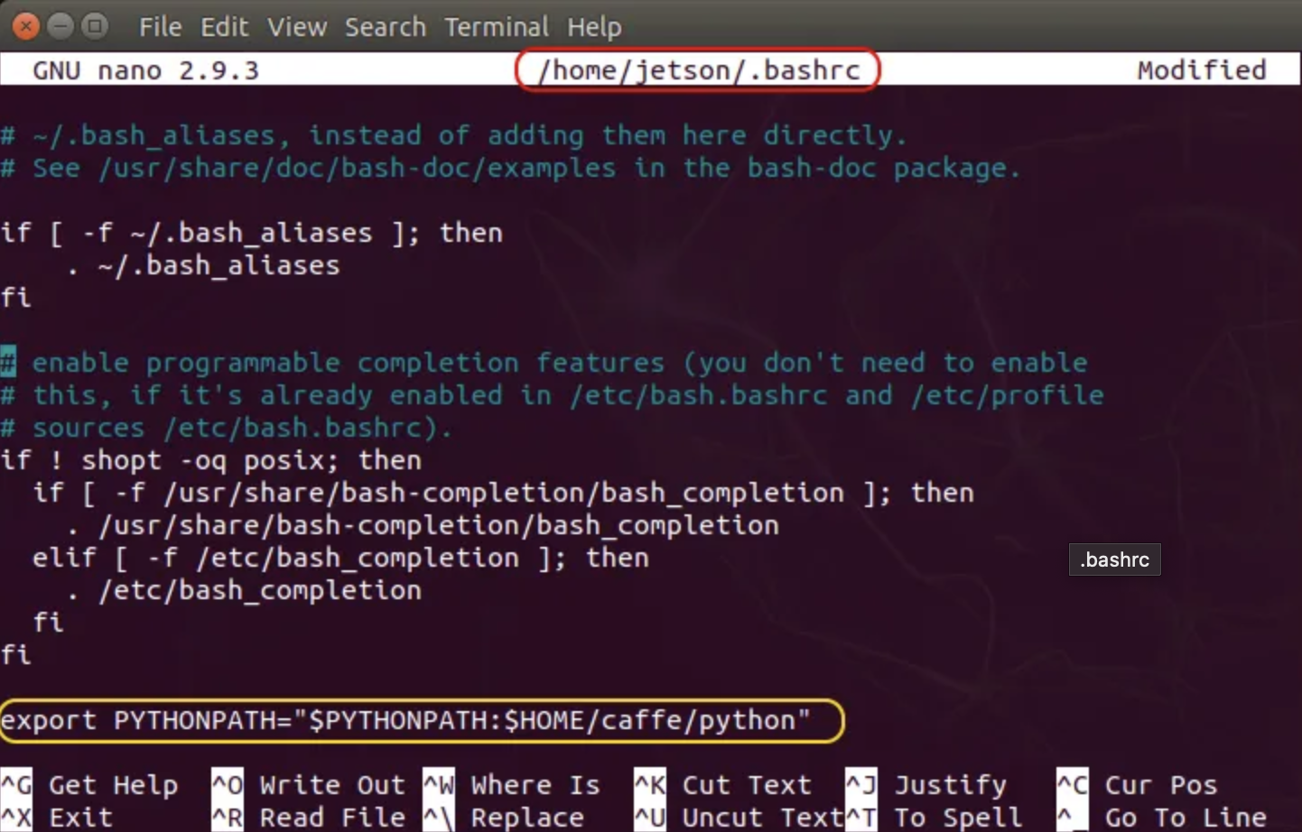
- Setup Jupyter notebook on jetson nano
- Install anaconda/miniforge:
Using a virtual environment can help prevent system instability when managing packages. Anaconda is a good toolset to manage environments and packages. While on Windows, Mac and Linux, we have the flexibility of using Anaconda, the ARM platform has limited choices. One such choice is miniforge(same use as Anaconda).
Run the code below to install miniforge3:
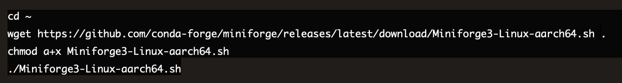


- Install some foundational python packages:
- Configure and create a new environment with anaconda:
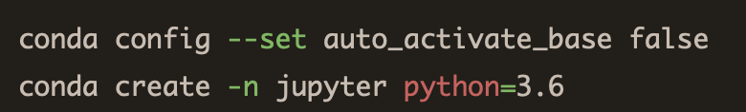

- Activate the new-create jupyter environment and install packages inside this environment:
$conda activate jupyter
$conda install jupyter matplotlib pandas numpy pillow scipy tqdm scikit-image scikit-learn seaborn cython h5py ipywidgets -c conda-forge

- Configure jupyter notebook:
$jupyter notebook --generate-config
$jupyter notebook password

$jupyter notebook --generate-config
$jupyter notebook password

we can edit the configuration file by using vim command:
$vim /home/xt/.jupyter/jupyter_notebook_config.py
- Run Jupyter Notebook in the new-create environment:
$conda activate jupyter
$jupyter notebook --no-browser

- Move the browser side of the Jupyter equation to a desktop:
Since we only connect the jetson nano with PuTTY and it can not access to the PC browser, we need to setup SSH tunneling to connect jupyter servel with our PC browser. First we need to know the ip address of the jetson device by using $ifconfig. Then type the command below into your PC terminal:
$ssh -L 8000:localhost:8888 xt@[your device ip]

- Finally connect to the jupyter server in your browser:
by inputting “localhost:8000” in your browser address bar and hit enter.
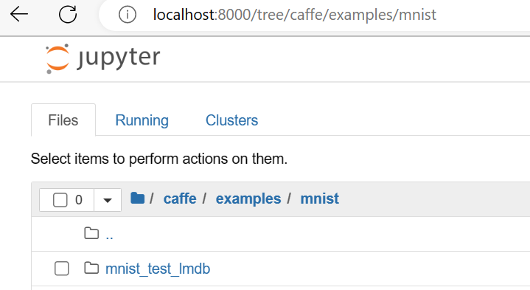
3.Raw file of python_confmat.py：
import caffe
import json
import numpy as np
import sys

import sklearn.metrics

class PythonConfMat(caffe.Layer):
"""
Compute the Accuracy with a Python Layer
"""

def setup(self, bottom, top):
# check input pair
if len(bottom) != 2:
raise Exception("Need two inputs.")

self.num_labels = bottom[0].channels
params = json.loads(self.param_str)
self.test_iter = params['test_iter']
self.conf_matrix = np.zeros((self.num_labels, self.num_labels))
self.current_iter = 0

def reshape(self, bottom, top):
# bottom[0] are the net's outputs
# bottom[1] are the ground truth labels

# Net outputs and labels must have the same number of elements
if bottom[0].num != bottom[1].num:
raise Exception("Inputs must have the same number of elements.")

# accuracy output is scalar
top[0].reshape(1)

def forward(self, bottom, top):
self.current_iter += 1

# predicted outputs
pred = np.argmax(bottom[0].data, axis=1)
accuracy = np.sum(pred == bottom[1].data).astype(np.float32) / bottom[0].num
top[0].data[...] = accuracy

# compute confusion matrix
self.conf_matrix += sklearn.metrics.confusion_matrix(bottom[1].data, pred, labels=range(self.num_labels))

if self.current_iter == self.test_iter:
self.current_iter = 0
sys.stdout.write('\nCAUTION!! test_iter = %i. Make sure this is the correct value' % self.test_iter)
sys.stdout.write('\n"param_str: \'{"test_iter":%i}\'" has been set in the definition of the PythonLayer' % self.test_iter)
sys.stdout.write('\n\nConfusion Matrix')
sys.stdout.write('\t'*(self.num_labels-2)+'| Accuracy')
sys.stdout.write('\n'+'-'*8*(self.num_labels+1))
sys.stdout.write('\n')
for i in range(len(self.conf_matrix)):
for j in range(len(self.conf_matrix[i])):
sys.stdout.write(str(self.conf_matrix[i][j].astype(np.int))+'\t')
sys.stdout.write('| %3.2f %%' % (self.conf_matrix[i][i]*100 / self.conf_matrix[i].sum()))
sys.stdout.write('\n')
sys.stdout.write('Number of test samples: %i \n\n' % self.conf_matrix.sum())
# reset conf_matrix for next test phase
self.conf_matrix = np.zeros((self.num_labels, self.num_labels))

def backward(self, top, propagate_down, bottom):
Pass

